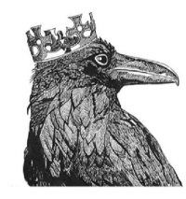
Perran-ar-worthal
Local History Group
PRESENTS:
SHOUT KERNOW
Celebrating Cornwall’s Pub Songs
With Hilary Coleman and Sally Burley
Tuesday March 28th 7.30pm at the Perranwell Centre.
Come along and join in…it will be fun!!
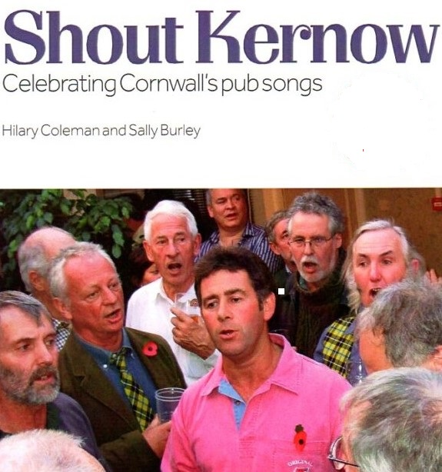
Hilary Coleman was inspired to undertake the project Shout Kernow because of her growing realisation of how important this pub singing is in Cornish culture.
She co-founded the ground-breaking Cornish bands Gwaryoryon, Sowena and most recently Dalla (2000) and was heavily involved in researching and arranging Cornish traditional music for these bands which included writing songs and tunes in the idiom and using the Cornish language.In 1998 she set up Cumpas offering Cornish music workshops for schools, arranging and writing songs with children. She introduced Cornish songs, including the pub harmony singing tradition to many choirs and now runs the Red River Singers in Pool.
In 2004 Hilary became a bard of the Cornish Gorseth for her services to Cornish music
Sally Burley’s interest in Cornish culture and history has come through her father Joseph Mills, a keen historian who co-wrote The History of St Day. She met Hilary Coleman when her children joined a Cornish dance troupe, Hilary was playing clarinet in the band Sowena who played for them. Sally sang with Hilary in the Tregajorran Singers and now helps with the running of the Red River Singers.

